**Clinical Decision Support (CDS) Content and Health Level 7 (HL7) - Compliant Knowledge Artifacts (KNARTs)**

**Women's Health: Cervical Cancer Screening Clinical Content White Paper**

**Department of Veterans Affairs (VA)**



**Knowledge Based Systems (KBS)**

**Office of Informatics and Information Governance (OIIG)**

**Clinical Decision Support (CDS)**

**Clinical Decision Support (CDS) Content and Health Level 7 (HL7) - Compliant Knowledge Artifacts (KNARTs): Women's Health: Cervical Cancer Screening Clinical Content White Paper**

by Department of Veterans Affairs (VA)

Publication date March 2018

**Contract: VA118-16-D-1008, Task Order (TO): VA-118-16-F-1008-0007**

**Table 1. Relevant KNART Information**

| **Women's Health KNART** | **Associated CLIN** |
| --- | --- |
| Cervical Cancer Screening - ECA Rule | CLIN0007BA |
| Cervical Cancer Screening - Order Set | CLIN0008AA |
| Cervical Cancer Screening - Documentation Template | CLIN0008CA |

**Table of Contents**

VA Subject Matter Expert (SME) Panel vi

Introduction vii

Conventions Used viii

1. Women's Health: Cervical Cancer Screening 1

1.1. Clinical Context 1

1.2. Knowledge Artifacts 1

2. Event-Condition-Action (*ECA*) Rule: Women's Health: Cervical Cancer Screening 3

2.1. Knowledge Narrative 3

2.2. Primary Level (trunk) cohort identification 3

2.2.1. Cervical Cancer Screening for 21-29 Years of Age: In Person 4

2.2.2. Cervical Cancer Screening for 21-29 Years of Age: Reporting 5

2.2.3. Cervical Cancer Screening for 30 to 65 Years of Age: In Person 5

2.2.4. Cervical Cancer Screening for 30 to 65 Years of Age: Reporting 6

2.2.5. Cervical Cancer Screening for Older than 65 Years of Age: In Person 7

2.2.6. Cervical Cancer Screening for Older than 65 Years of Age: Reporting 7

3. Documentation Template: Women's Health: Cervical Cancer Screening 9

3.1. Knowledge Narrative 9

3.2. History 9

3.3. Laboratory Studies 10

3.3.1. Laboratory Studies: Aged 21–29 Years. 10

3.3.2. Laboratory Studies: Aged 30–65 Years 11

3.3.3. Laboratory Studies: Aged Older Than 65 Years 11

3.4. Plan of Care 11

3.4.1. Plan: Aged 21–29 Years 12

3.4.2. Plan: Aged 30–65 Years 12

3.4.3. Plan: Aged Older Than 65 Years 13

4. Order Set: Women's Health: Cervical Cancer Screening 14

4.1. Knowledge Narrative 14

4.2. Cervical Cancer Screening 14

Bibliography/Evidence 15

A. Existing VA Artifacts 16

B. Cervical Cancer Screening Logic Diagrams 19

Acronyms 21

**List of Figures**

A.1. HPV Orders 16

A.2. Gynecology Consult for Abnormal Pap Smear 16

A.3. Pap Smear Screening Clinical Reminder 17

A.4. Pap Smear Screening Clinical Reminder with Record Outside Pap section expanded 18

B.1. Cervical Cancer Screening *ECA* Rules 19

B.2. Cervical Cancer Screening *ECA* Rules - Reporting 20

**List of Tables**

1. Relevant KNART Information ii

1.1. Clinical Context Domains 1

**VA Subject Matter Expert (SME) Panel**

| **Name** | **Title** | **Project Role** |
| --- | --- | --- |
| C. Yvette Williams-Harris, MD, MPH | Physician, 1670 Clairmont Rd Atlanta, GA 30033 | SME, Primary |
| Megan Gerber, MD, MPH | Physician, VA Boston Healthcare System, 150 South Huntington Ave Boston, MA 02130 | SME, Secondary |
| Caitlin M. Cusack, MD, MPH | Contractor- Physician Informaticist, Office of Women's Health Services, 8455 Colesville Rd, 12th Floor Silver Spring, MD 20910 | SME |

**Introduction**

The *VA* is committed to improving the ability of clinicians to provide care for patients while increasing quality, safety, and efficiency. Recognizing the importance of standardizing clinical knowledge in support of this goal, VA is implementing the HL7 Knowledge Artifact Specification for a wide range of VA clinical use cases. Knowledge Artifacts, referred to as *KNARTs*, enable the structuring and encoding of clinical knowledge so the knowledge can be integrated with electronic health records to enable clinical decision support.

The purpose of this Clinical Content White Paper (*CCWP*) is to capture the clinical context and intent of KNART use cases in sufficient detail to provide the *KNART* authoring team with the clinical source material to construct the corresponding knowledge artifacts using the *HL7* Knowledge Artifact Specification. This paper has been developed using material from a variety of sources: VA artifacts, clinical practice guidelines, evidence in the body of medical literature, and clinical expertise. After reviewing these sources, the material has been synthesized and harmonized under the guidance of VA subject matter experts to reflect clinical intent for this use case.

Unless otherwise noted, items within this white paper (e.g., documentation template fields, orderable items, etc.) are chosen to reflect the clinical intent at the time of creation. To provide an exhaustive list of all possible items and their variations is beyond the scope of this work.

**Conventions Used**

Conventions used within the knowledge artifact descriptions include:

<obtain> : Indicates a prompt to obtain the information listed

* If possible, the requested information should be obtained from the underlying system(s). Otherwise, prompting the user for information may be required
* Default Values: Unless otherwise noted, <obtain> indicates to obtain the most recent observation. It is recognized that this default time-frame value may be altered by future implementations

[...]: Square brackets enclose explanatory text that indicates some action on the part of the clinical user, or general guidance to the clinical or technical teams. Examples include, but are not limited to:

[Begin ...], [End ...]: Indicates the start and end of specific areas to clearly delineate them for technical purposes.

[Activate ...]: Initiates another knowledge artifact or knowledge artifact section.

[Section Prompt: ...]: If this section is applicable, then the following prompt should be displayed to the user.

[Section Behavior: ...]: Indicates technical constraints or considerations for the selection of items outlined in the section prompt.

[Attach: ...]: Indicates that the specified item (e.g. procedure or result interpretation) should be attached to the documentation template if available.

[Link: ...]: Indicates that rather than attaching an item (e.g. image), a link should be included in the documentation template.

[Clinical Comment: ...]: Indicates technical considerations or notes to be utilized for KNART authoring and at time of implementation planning.

[Technical Note: ...]: Indicates technical considerations or notes to be utilized for KNART authoring and at time of implementation planning.

[If ...]: Indicates the beginning of a conditional section.

[Else, ...]: Indicates the beginning of the alternative branch of a conditional section.

[End if ...]: Indicates the end of a conditional section.

☐ [Check box]: Indicates items that should be selected based upon the section selection behavior.

**Chapter 1. Women's Health: Cervical Cancer Screening**

[Begin Women’s Health: Cervical Cancer Screening.]

**1.****1. Clinical Context**

[Begin Clinical Context.]

Cervical cancer is largely a preventable disease due to the success of early treatment enabled by appropriate preventive screening (ACOG 2016). Therefore, it is imperative that women be screened according to evidence-based guidelines. Screening is particularly important, as secular trends indicate decreasing levels of screening among women and the persistence of health care disparities among certain groups of women based on race, ethnicity, and socioeconomic factors.

The Cervical Cancer Screening KNART set is intended to prompt providers to identify a woman's cervical cancer risk category; counsel her about that risk; identify her screening preferences; screen based on age, risk, and patient preference; and document the entire process.

**Table 1.1. Clinical Context Domains**

|  |  |
| --- | --- |
| Target User | Provider to include Primary Care, Designated Women’s Health Providers, and Gynecologists |
| Patient | Female that is at least 21 years of age or older |
| Priority | Routine |
| Specialty | Primary Care, Designated Women’s Health Providers, and Gynecology |
| Location | Outpatient |

[End Clinical Context.]

**1.2. Knowledge Artifacts**

[Begin Knowledge Artifacts.]

This section describes the Clinical Decision Support (CDS) knowledge artifacts specific to cervical cancer screening. These knowledge artifacts are intended for users providing primary and preventative care to women to ensure that timely cervical cancer screening is performed and that women’s preferences are incorporated into the decision-making process. Target clinical users include primary care providers, women's health clinical providers and gynecologists. The patient cohort includes women aged 21 years and older with an intact cervix and without cervical cancer risk factors.

Women with the following risk factors are excluded from the patient cohort as they are followed in accordance with alternative protocols:

* Women who have an immune disorder such as being Human Immunodeficiency Virus (*HIV*) positive.
* Women with a history of high-grade precancerous cervical lesion(s) or cervical cancer.
* Women with in utero exposure to diethylstilbestrol.

This section describes the CDS knowledge artifacts that are part of the Cervical Cancer Screening group, and include:

* An Event-Condition-Action (*ECA*) Rule: Cervical Cancer Screening
* Rule logic that describes the activation of the documentation template and order set.
* Actions may include activating documentation templates or order sets.
* A Documentation Template: Cervical Cancer Screening
* A template that facilitates documentation of the management of a patient’s cervical cancer screening.
* Includes logic for the appropriate display of the documentation sections.
* An Order Set: Cervical Cancer Screening
* Orderable items associated with management of cervical cancer screening.
* Includes logic for the appropriate display of the order set.

[End Knowledge Artifacts.]

[End Women’s Health: Cervical Cancer Screening.]

**Chapter 2. Event-Condition-Action (*ECA*) Rule: Women's Health: Cervical Cancer Screening**

[Begin ECA Rule.]

**2.1. Knowledge Narrative**

[Begin Knowledge Narrative.]

[See Clinical Context in Chapter 1.]

The Event-Condition-Action Rule will assure:

* Clinicians have access to the current guidelines at the point of care to guide their counseling; and
* Patients are notified when they are due for cervical cancer screening either during or outside of in-person clinical visits.

[Clinical Comment: The purpose of the *ECA* rule for cervical cancer screening is to assess the patient’s cervical cancer screening status and if warranted, to document cervical cancer risk and screening desires as well as to order the recommended test/screen.]

[End Knowledge Narrative.]

**2.2. Primary Level (trunk) cohort identification**

**Event**

[Begin Event]

* Opening of the patient record during an outpatient visit to primary care provider, designated women’s health provider or gynecologist,

OR.

* System run of preventive screening rules, run monthly.

[End Event]

**Conditions**

[Begin Conditions]

* Include female patients aged 21 years or older.
* Exclude women who have had a total hysterectomy (cervix + uterus), women who have congenital absence of the cervix, and women who meet any of the following high-risk criteria:
* Immunosuppression; or
* Presence of *HIV* infection; or
* Exposure to diethylstilbestrol in utero; or
* A history of high-grade dysplasia or prior treatment for Cervical Intra-epithelial Neoplasia (*CIN*) 2, CIN 3, or cervical cancer; or
* Women in whom screening has been discontinued due to:
* life expectancy less than 10 years
* history of adequate screening among women over 65

[Technical Note: Adequate negative prior screening results are defined as 3 consecutive negative cytology results or 2 consecutive negative co-test results within the previous 10 years, with the most recent test performed within the past 5 years.]

[End Conditions]

**Actions**

[Begin Actions]

* Activate Chapter 2, sections 2.2.1- 2.2.6

[End Actions]

**2.2.1. Cervical Cancer Screening for 21-29 Years of Age: In Person**

[Begin Cervical Cancer Screening for 21-29 years of age: In Person.]

**Event**

[Begin Event]

* Opening of the patient record during an outpatient visit to primary care provider, designated women’s health provider or gynecologist.

[End Event]

**Conditions**

[Begin Conditions]

* Patient age is ≥ 21 to < 30 years old
* No cervical cytology exam within the past 3 years or patient coming due in the next 60 days.

[Technical Note: If Due Date > Today + 60 Days, stop.]

[End Conditions]

**Actions**

[Begin Actions]

* Open the Cervical Cancer Screening Documentation Template
* Open the Cervical Cancer Screening Order Set

[Technical Note: Make sure the associated recommendations and guidelines for the age group are available to the provider.]

[End Actions]

[End Cervical Cancer Screening for 21-29 years of age: In Person .]

**2.2.2. Cervical Cancer Screening for 21-29 Years of Age: Reporting**

[Begin Cervical Cancer Screening for 21-29 years of age: Reporting.]

**Event**

[Begin Event]

* Monthly system run of preventative screening rules

[End Event]

**Conditions**

[Begin Conditions]

* Patient is ≥ 21 to < 30 years old
* Has had no cervical cytology exam within the past 3 years
* Due Date is within 30 days in the past and 60 days in the future of the system run date

[Technical Note: Given a monthly system run, this condition results in 3 notifications being sent to the patient.]

[End Conditions]

**Actions**

[Begin Actions]

* Send patient cervical cancer screening “due” notification

[Technical Note: Make sure the associated recommendations and guidelines for the age group are available to the care team.]

[End Actions]

[End Cervical Cancer Screening for 21-29 years of age: Reporting.]

**2.2.3. Cervical Cancer Screening for 30 to 65 Years of Age: In Person**

[Begin Cervical Cancer Screening for 30-65 Years of Age: In Person.]

**Event**

[Begin Event]

* Opening of the patient record during an outpatient visit to primary care provider, designated women’s health provider or gynecologist.

[End Event]

**Conditions**

[Begin Conditions]

* Patient age is ≥ 30 and ≤ 65 years old
* Has had none of the following screens:
* Cervical Cytology within the past 3 years, or
* Cotesting (cervical cytology and cervical Human Papillomavirus (*HPV*) screen) within the past 5 years

[Technical Note: If Due Date > Today + 60 Days, stop.]

* Open Cervical Cancer Screening Documentation Template.
* Open Cervical Cancer Screening Order Set

[Technical Note: Make sure the associated recommendations and guidelines for the age group are available to the provider.]

[End Actions]

[End Cervical Cancer Screening for 30-65 Years of Age: In Person.]

**2.2.4. Cervical Cancer Screening for 30 to 65 Years of Age: Reporting**

[Begin Cervical Cancer Screening for 30-65 Years of Age: Reporting.]

**Event**

[Begin Event]

* Monthly system run of preventative screening rules

[End Event]

**Conditions**

[Begin Conditions]

* Patient age is ≥ 30 and ≤ 65 years old
* Has had none of the following screens:
* Cervical Cytology within the past 3 years, or
* Cotesting (cervical cytology and cervical Human Papillomavirus (*HPV*) screen) within the past 5 years

Due Date is within 30 days in the past and 60 days in the future of the system run date

[Technical Note: Given a monthly system run, this condition results in 3 notifications being sent to the patient.]

* Send patient cervical cancer screening “due” notification

[Technical Note: Make sure the associated recommendations and guidelines for the age group are available to the care team.]

[End Actions]

[End Cervical Cancer Screening for 30-65 Years of Age: Reporting.]

**2.2.5. Cervical Cancer Screening for Older than 65 Years of Age: In Person**

[Begin Cervical Cancer Screening for Older than 65 Years of Age: In Person.]

**Event**

[Begin Event]

* Opening of the patient record during an outpatient visit to primary care provider, designated women’s health provider or gynecologist.

[End Event]

**Conditions**

[Begin Conditions]

* Patient age > 65 years old
* Has had none of the following screens:
* Cervical Cytology within the past 3 years, or
* Cotesting (cervical cytology and cervical Human Papillomavirus (*HPV*) screen) within the past 5 years

[Technical Note: If Due Date > Today + 60 Days, stop.]

[End Conditions]

**Actions**

[Begin Actions]

* Open Cervical Cancer Screening Documentation Template
* Open Cervical Cancer Screening Order Set

[Technical Note: Make sure the associated recommendations and guidelines for the age group are available to the provider.]

[End Actions]

[End Cervical Cancer Screening for Older than 65 Years of Age: In Person.]

**2.2.6. Cervical Cancer Screening for Older than 65 Years of Age: Reporting**

[Begin Cervical Cancer Screening for Older than 65 Years of Age: Reporting.]

**Event**

[Begin Event]

* Monthly system run of preventative screening rules

[End Event]

**Conditions**

[Begin Conditions]

* Patient age > 65 years old
* Has had none of the following exams:
* Cervical Cytology within the past 3 years, or
* Cotesting (cervical cytology and cervical Human Papillomavirus (*HPV*) screen) within the past 5 years
* Due Date is within 30 days in the past and 60 days in the future of the system run date

[Technical Note: Given a monthly system run, this condition results in 3 notifications being sent to the patient.]

[End Conditions]

**Actions**

[Begin Actions]

* Send patient cervical cancer screening “due” notification

[Technical Note: Make sure the associated recommendations and guidelines for the age group are available to the care team.]

[End Actions]

[End Cervical Cancer Screening for Older than 65 Years of Age: Reporting.]

[End ECA Rule.]

**Chapter 3. Documentation Template: Women's Health: Cervical Cancer Screening**

[Begin Documentation Template.]

[Technical Note: This documentation template should be made available for patients for whom the Cervical Cancer Screening *ECA* Rule KNART is activated (i.e., criteria met).]

**3.1. Knowledge Narrative**

[Begin Knowledge Narrative.]

[See Clinical Context in Chapter 1.]

[Clinical Comment: The Cervical Cancer Screening Documentation Template will guide clinicians in their conversations with a woman based upon her age and risk-based screening preferences as well as allow for the efficient documentation of those conversations and capture the woman's personal preferences.]

[Technical Note: Discrete data elements will be acquired through a series of questions and answers. Any information that can be obtained from the system should pre-populate the field in a manner that is apparent to the user.]

[Technical Note: The template should automatically adjust to be specific to the following age groups: 21-29, 30-65 and older than 65 years of age.]

[Technical Note: The template should allow for the documentation of prior cervical cancer screening and results from outside of the organization.]

[End Knowledge Narrative.]

**3.****2. History**

[Begin History section.]

[Section Prompt: Patient Age.]

<obtain> Age in years

[Section Prompt: History of high-grade dysplasia or prior treatment for Cervical Intraepithelial Neoplasia (*CIN*) 2 or higher?]

[Section Selection Behavior: Select one. Required.]

☐ Yes

<obtain> Details

☐ No

[Previously treated for *CIN* 2, *CIN* 3, or Cervical Cancer?]

[Section Selection Behavior: Select one. Required.]

☐ Yes

<obtain> Details

☐ No

[Section Prompt: Exposed to Diethylstilbestrol in Utero?]

[Section Selection Behavior: Select one. Required.]

☐ Yes

<obtain> Details

☐ No

[Section Prompt: Hysterectomy with Removal of Cervix (Total Hysterectomy)?]

[Section Selection Behavior: Select one. Required.]

☐ Yes

<obtain> Details

☐ No

[Section Prompt: Infected with *HIV*?]

[Section Selection Behavior: Select one. Required.]

☐ Yes

<obtain> Details

☐ No

[Section Prompt: Immunocompromised (Other Than *HIV*)?]

[Section Selection Behavior: Select one. Required.]

☐ Yes

<obtain> Details

☐ No

[Section Prompt: Significant Comorbidity Limits Life Span to < 10 Years?]

[Section Selection Behavior: Select one. Required.]

☐ Yes

<obtain> Details

☐ No

[End History section.]

**3.3. Laboratory Studies**

[Begin Laboratory Studies section.]

**3.3.1. Laboratory Studies: Aged 21–29 Years.**

[This section of the documentation template should be made available when the ECA Rule Cervical Cancer Screening for 21-29 Years of Age: In Person is executed.]

[Section Prompt: Most Recent Cervical Cytology.]

<obtain> Results

<obtain> Date

**3.3.2. Laboratory Studies: Aged 30–65 Years**

[This section of the documentation template should be made available when the ECA Rule Cervical Cancer Screening for 30 to 65 Years of Age: In Person is executed.]

[Section Prompt: Most Recent Cervical Cytology.]

<obtain> Results

<obtain> Date

[Section Prompt: Most Recent Cervical *HPV* Screening.]

<obtain> Results

<obtain> Date

**3.3.3. Laboratory Studies: Aged Older Than 65 Years**

[This section of the documentation template should be made available when the ECA Rule Cervical Cancer Screening for Older than 65 Years of Age: In Person is executed.]

[Section Prompt: Most Recent Cervical Cytology.]

<obtain> Results

<obtain> Date

[Section Prompt: Second-Most Recent Cervical Cytology.]

<obtain> Results

<obtain> Date

[Section Prompt: Third-Most Recent Cervical Cytology.]

<obtain> Results

<obtain> Date

[Section Prompt: Most Recent Cervical *HPV* Screen.]

<obtain> Results

<obtain> Date

[Section Prompt: Second-Most Recent Cervical *HPV* Screen.]

<obtain> Results

<obtain> Date

[End Laboratory Studies section.]

**3.****4. Plan of Care**

[Begin Plan of Care.]

[Section Prompt: Due Date for Cervical Cancer Screening.]

<obtain> Due Date

[Technical Note: Due Date is calculated per patient-relevant ECA rule.]

**3.4.1. Plan: Aged 21–29 Years**

[This section of the documentation template should be made available when the ECA Rule Cervical Cancer Screening for 21-29 Years of Age: In Person is executed.]

[Section Prompt: Cervical Cancer Preventive Screening Plan.]

[Section Selection Behavior: Select one. Required.]

☐ Continue Screening Every Three Years with Cervical Cytology Alone

☐ Discontinue Screening Due to Life Expectancy < 10 Years

☐ Other

<obtain> Details

[Section Prompt: Plan Discussed with and Agreed to by Patient?]

[Section Selection Behavior: Select one. Required.]

☐ Yes

☐ No

<obtain> Explanation

**3.4.2. Plan: Aged 30–65 Years**

[This section of the documentation template should be made available when the ECA Rule Cervical Cancer Screening for 30 to 65 Years of Age: In Person is executed.]

[Section Prompt: Cervical Cancer Preventive Screening Plan.]

[Section Selection Behavior: Select one. Required.]

☐ Continue Screening Every Three Years with Cervical Cytology Alone

☐ Continue Screening Every Five Years with Cotesting (Cervical Cytology Plus Cervical *HPV* Screening)

☐ Discontinue Screening Due to Life Expectancy < 10 Years

☐ Other

<obtain> Details

[Section Prompt: Plan Discussed with and Agreed to by Patient?]

[Section Selection Behavior: Select one. Required.]

☐ Yes

☐ No

<obtain> Explanation

**3.4.3. Plan: Aged Older Than 65 Years**

[This section of the documentation template should be made available when the ECA Rule Cervical Cancer Screening for Older than 65 Years of Age: In Person is executed.]

[Section Prompt: Cervical Cancer Screening Plan.]

[Section Selection Behavior: Select one. Required.]

☐ Continue Screening Every Three Years with Cervical Cytology Alone

☐ Continue Screening Every Five Years with Cotesting (Cervical Cytology Plus Cervical *HPV* Screening)

☐ Discontinue Screening Due to Life Expectancy < 10 Years

☐ Discontinue Screening because adequate screening has been completed (Three Consecutive Negative Cytology Results within the Last 10 Years OR Two Consecutive Negative Cotesting Results within the Last 10 Years, with the Most Recent Screening of either type Performed within the Past 5 Years)

☐ Other

<obtain> Details

[Section Prompt: Plan Discussed with and Agreed to by Patient?]

[Section Selection Behavior: Select one. Required.]

☐ Yes

☐ No

<obtain> Explanation

[End Plan of Care.]

[End Documentation Template.]

**Chapter 4. Order Set: Women's Health: Cervical Cancer Screening**

[Begin Order Set.]

[Technical Note: This Order Set is to be made available for patients for whom Cervical Cancer Screening *ECA* Rule KNART was positive.]

**4.****1. Knowledge Narrative**

[Begin Knowledge Narrative.]

[See Clinical Context in Chapter 1.]

[Clinical Comment: The order set allows users to order cervical cancer screening, including cervical cytology and *HPV* co-testing, quickly and efficiently.]

[Technical Note: Currently, VA users can enter orders directly or they can order from within the clinical reminder dialog (see Appendix A).]

[End Knowledge Narrative.]

**4.****2. Cervical Cancer Screening**

[Begin Cervical Cancer Screening.]

[Section Prompt: Laboratory Studies.]

[Section Selection Behavior: Select one or more. Optional.]

☐ Papanicolaou test cervical cells for cervical cancer screening routine

☐ Liquid-based cytology cervical cells for cervical cancer screening routine

[Section Prompt: If Age >= 30, then co-testing for HPV and cervical cytology is recommended, although cervical cytology alone is an option if patient prefers.]

☐ *HPV* screen cervical cells as part of cervical cancer cotesting routine

[Section Prompt: Patient and Caregiver Education.]

[Selection Behavior: Select one. Optional.]

☐ Cervical cancer screening education (Pap smear testing, liquid-based cervical cytology, *HPV* testing, and cervical cancer) routine

[End Cervical Cancer Screening.]

[End Order Set.]

**Bibliography/Evidence**

Committee on Practice Bulletins—Gynecology.. *Practice Bulletin No. 168: Cervical Cancer Screening and Prevention*. *Obstet Gynecol*. 2016. 128. (4). e111-e130.

Health Promotion and Disease Prevention.. *Provider Fact Sheet: Cervical Cancer Screening. National Center for Health Promotion and Disease Prevention website*. https://www.prevention.va.gov/docs/CervicalCProvider.pdf.. June 2013.

*Cervical Cancer Screening Guidelines for Average Risk Women*. https://www.cdc.gov/cancer/cervical/pdf/guidelines.pdf. July 2017.

Committee on Gynecologic Practice. *Committee Opinion No. 534: Well-Woman Visit. Obstetrics and Gynecology*. August 2012. 120. (2 Pt 1). 421.

*Department of Veteran Affairs National Center for Health Promotion and Disease Prevention, Cervical Cancer Screening*. https://www.prevention.va.gov/Preventing_Diseases/Screening_for_Cervical_Cancer.asp#frequency. July 2017.

[Massad, 2013] LS Massad, MH Einstein, WK Huh, HA Katki, WK Kinney, M Schiffman, D Solomon, N Wentzensen, and HW. Lawson. “2012 Updated Consensus Guidelines For The Management Of Abnormal Cervical Cancer Screening Tests And Cancer Precursors”. *stetrics and Gynecology*. April 1, 2013. 121. (4). 829-46.

*United States Preventive Task Force (USPTF) Cervical Cancer Screening Guidelines*. https://www.uspreventiveservicestaskforce.org/Page/Document/UpdateSummaryFinal/cervical-cancer-screening. July 2017.

**Appendix A. Existing VA Artifacts**

**Figure A.1. Pap Smear Screening Clinical Reminder**

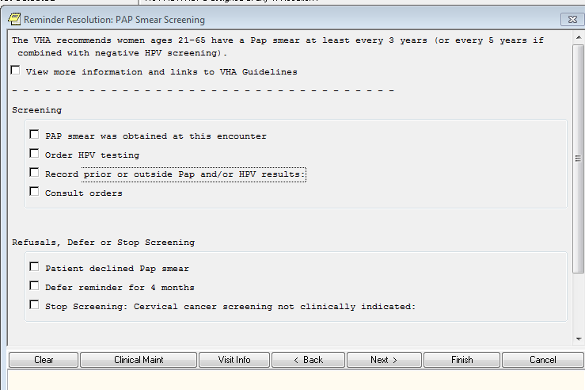

**Figure A.2 Pap Smear Screening Clinical Reminder with Record Outside Pap section expanded**

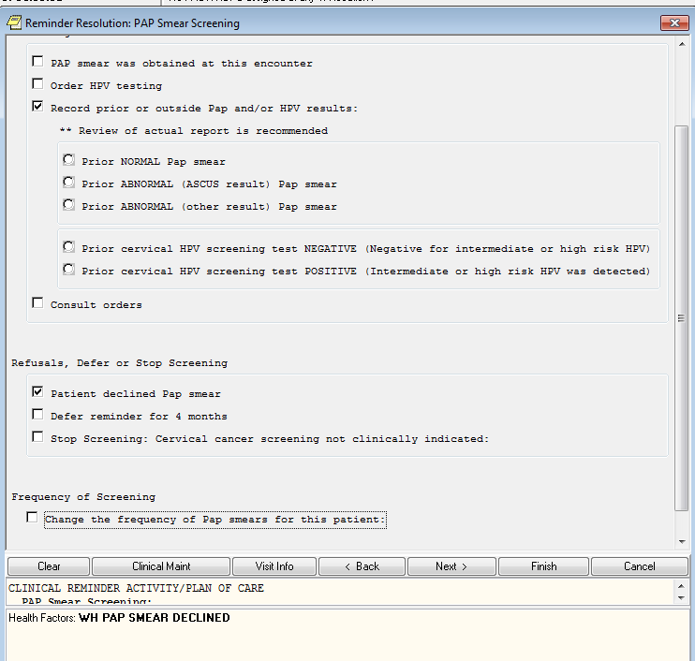

**Figure A.3. HPV Orders**

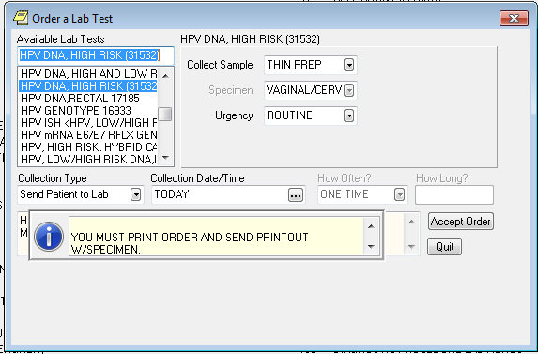

**Appendix B. Cervical Cancer Screening Logic Diagrams**

**Figure B.1. Cervical Cancer Screening *ECA* Rules**

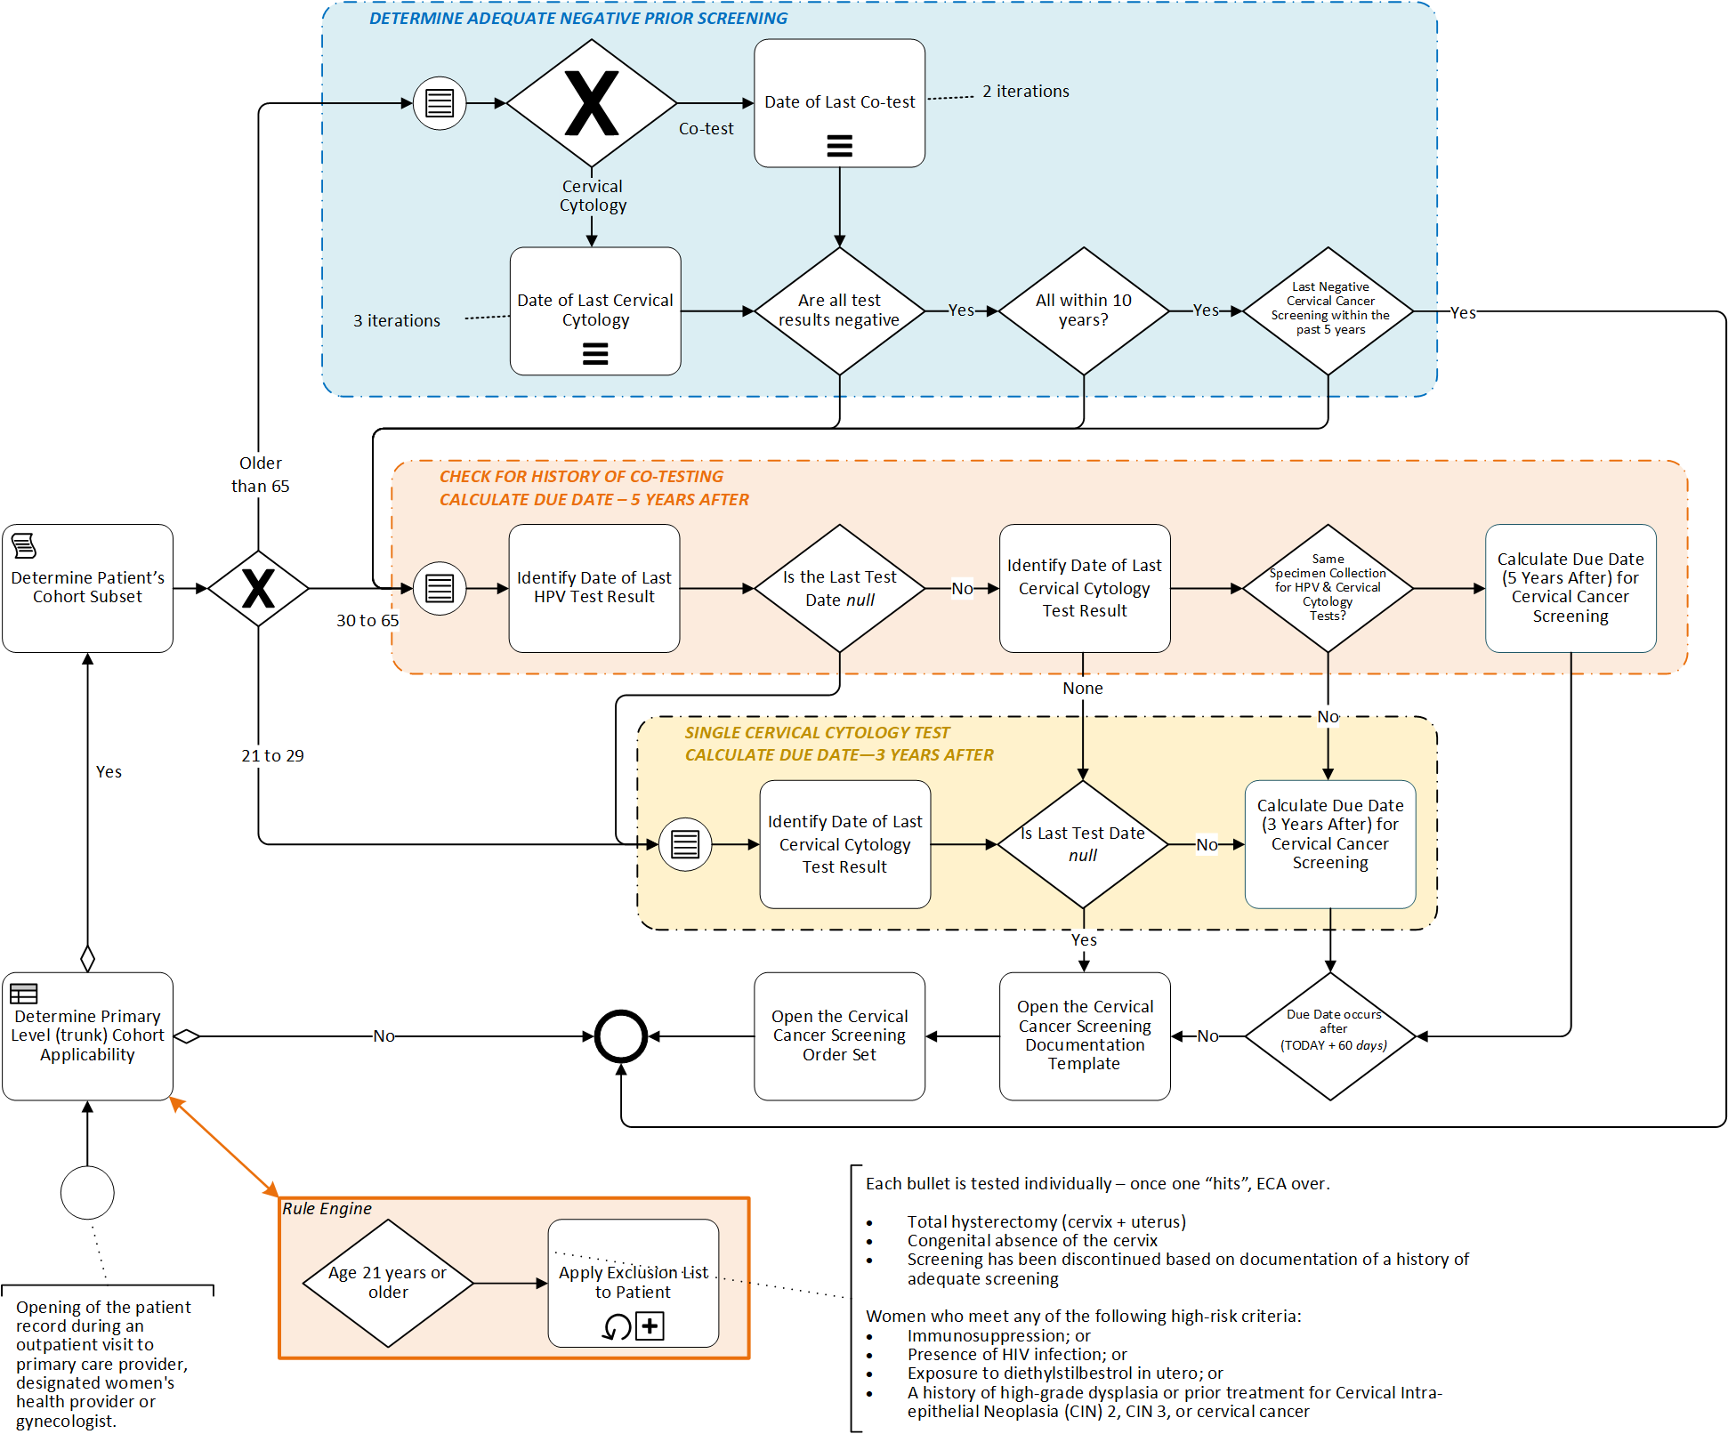

**Figure B.2. Cervical Cancer Screening *ECA* Rules – Reporting**

[Technical note: this logic is referencing logic in Figure B.1]

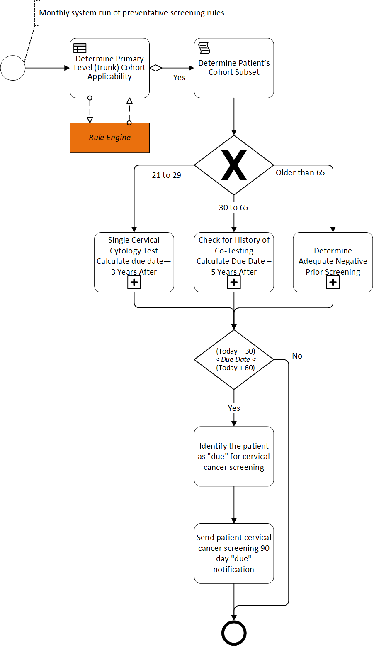

**Acronyms**

CCWP Clinical Content White Paper

CIN Cervical Intraepithelial Neoplasia

ECA Event Condition Action

HIV Human Immunodeficiency Virus

HL7 Health Level 7

HPV Human Papillomavirus

KNART Knowledge Artifact

KNARTs Knowledge Artifacts







VA Department of Veteran Affairs